GOODS ISSUE TO PROJECT STOCK

Home - Personal - Microsoft​ Edge
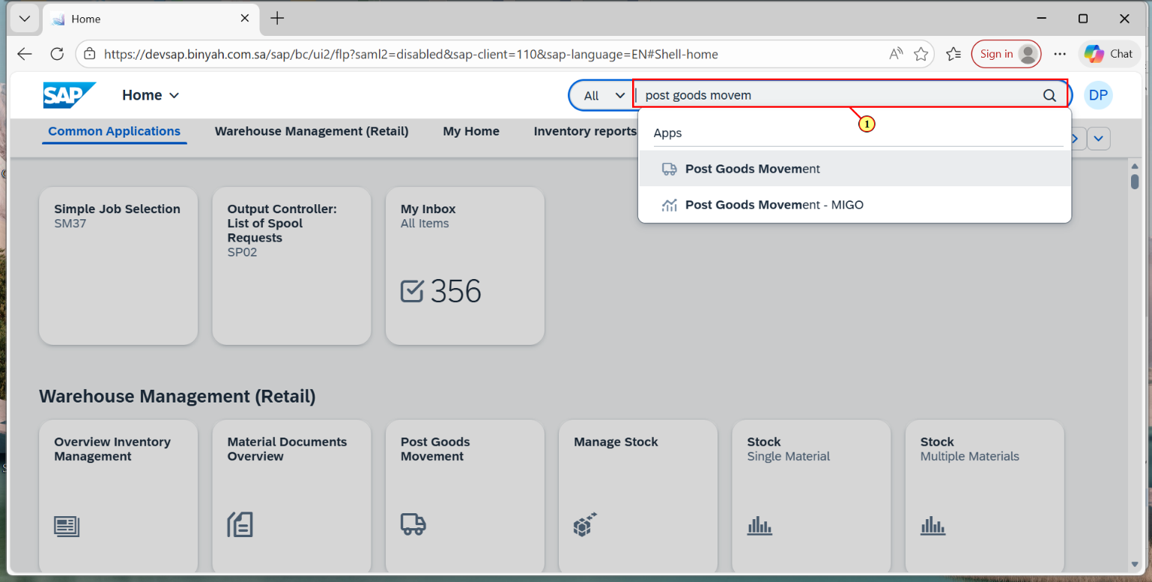
Step | Action
(1) | Search and Open "Post Goods Movement".

Display Material Document - Personal - Microsoft​ Edge
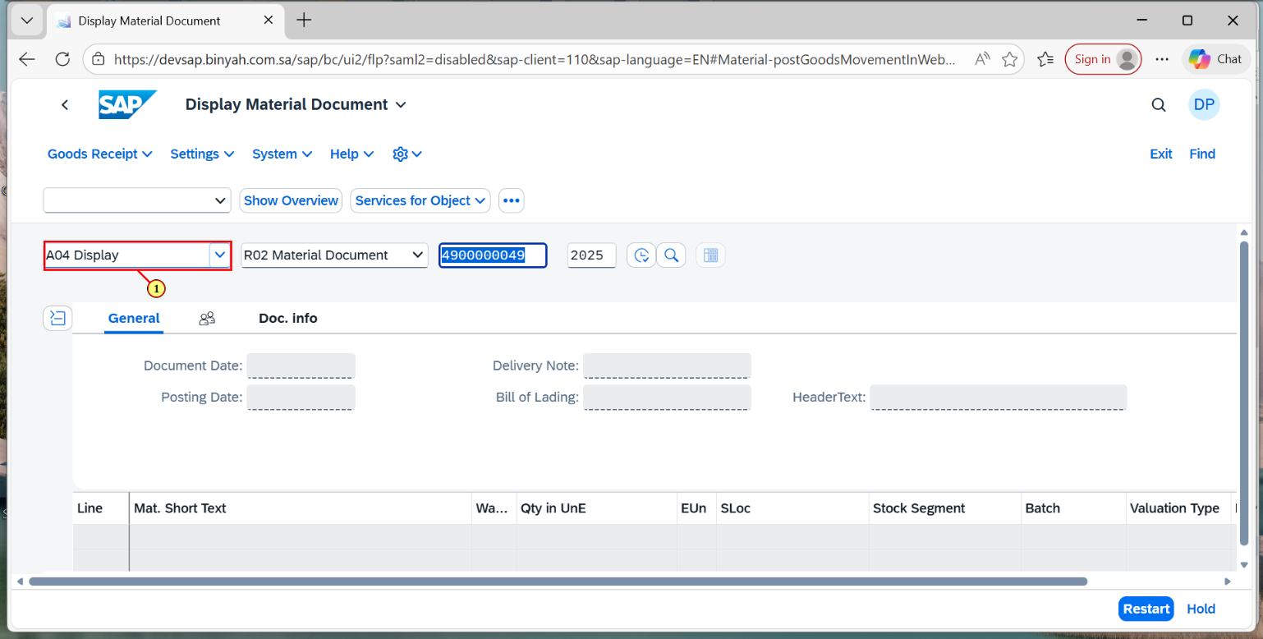
Step | Action
(1) | Select "Goods Issue".

Goods Issue Other - Personal - Microsoft​ Edge
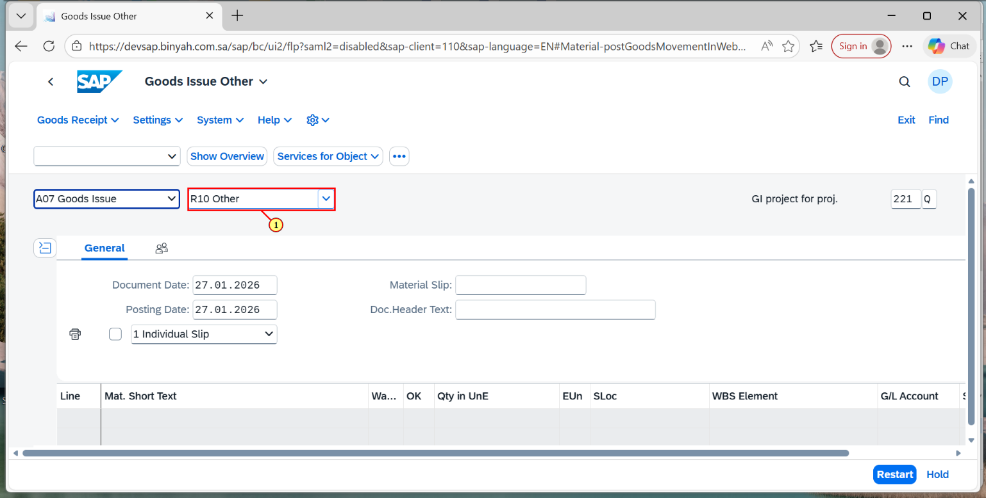
Step | Action
(1) | Select "Other".

Goods Issue Other - Personal - Microsoft​ Edge
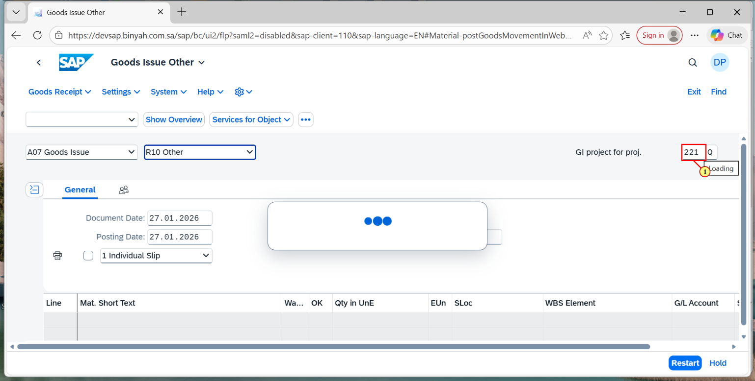
Step | Action
(1) | Select "221".

Goods Issue Other - Personal - Microsoft​ Edge
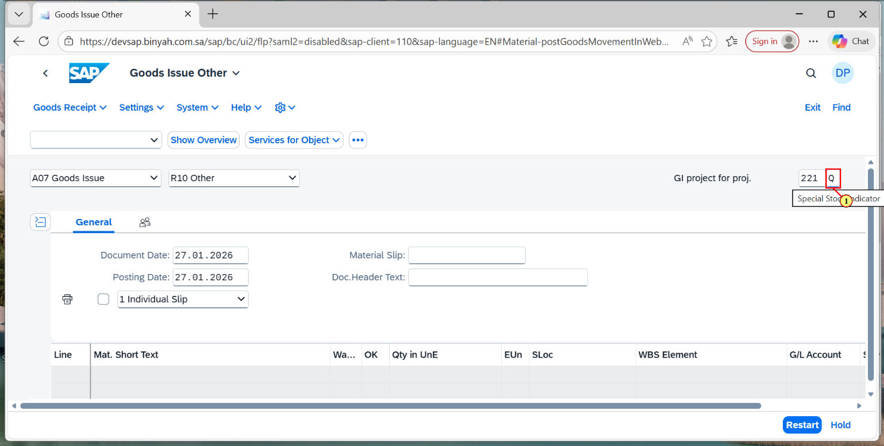
Step | Action
(1) | Enter the Special Stock Indicator "Q".

Goods Issue Other - Personal - Microsoft​ Edge
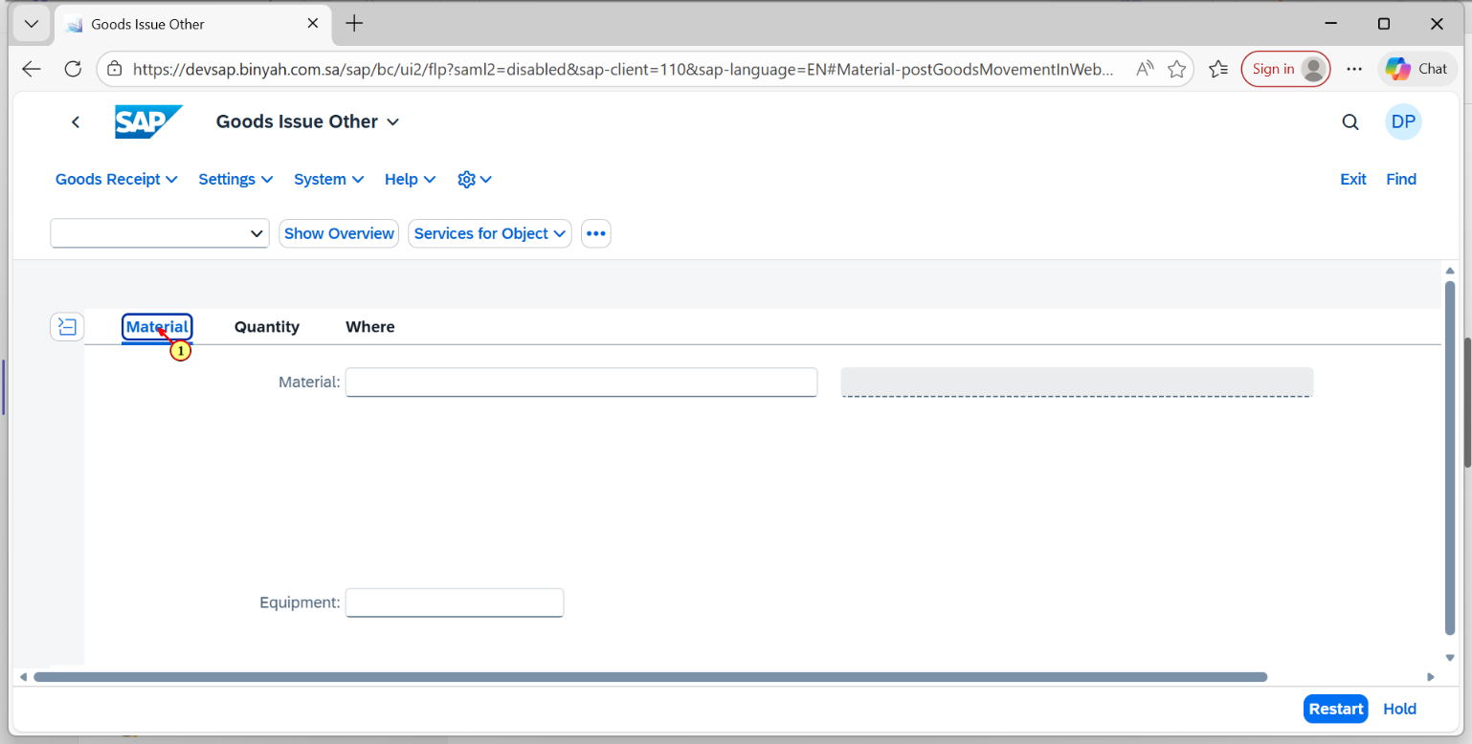
Step | Action
(1) | Click on "Material"Section.

Goods Issue Other - Personal - Microsoft​ Edge
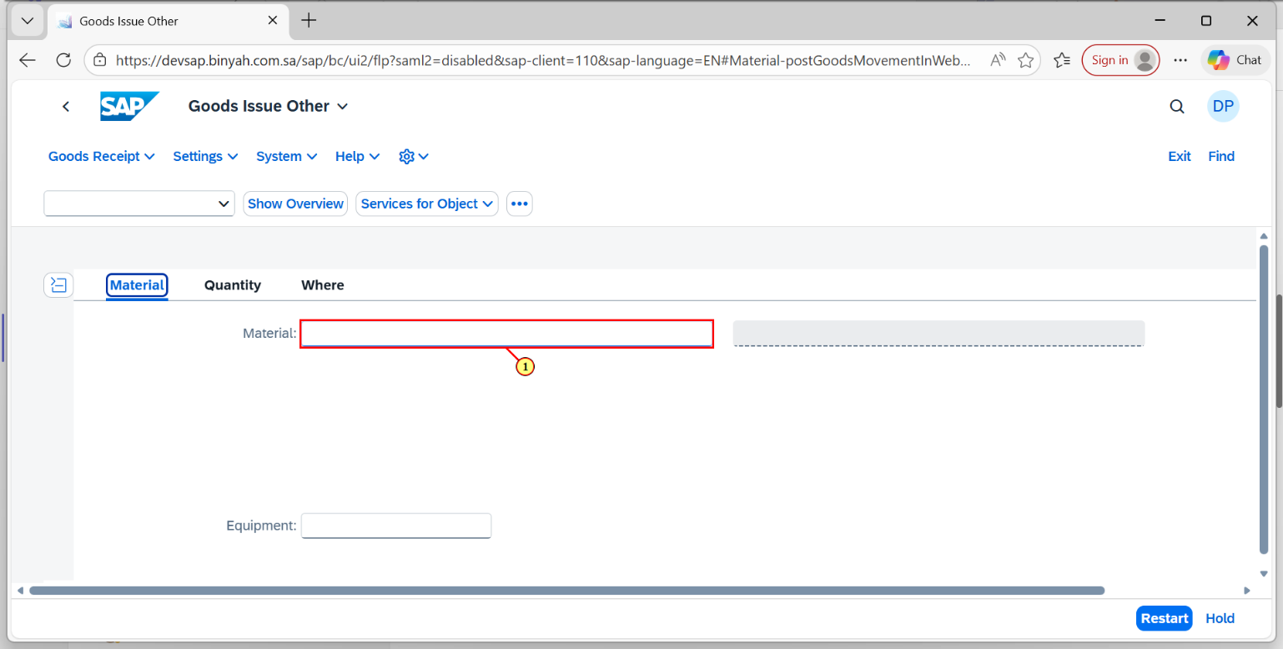
Step | Action
(1) | Enter the Material.

Goods Issue Other - Personal - Microsoft​ Edge
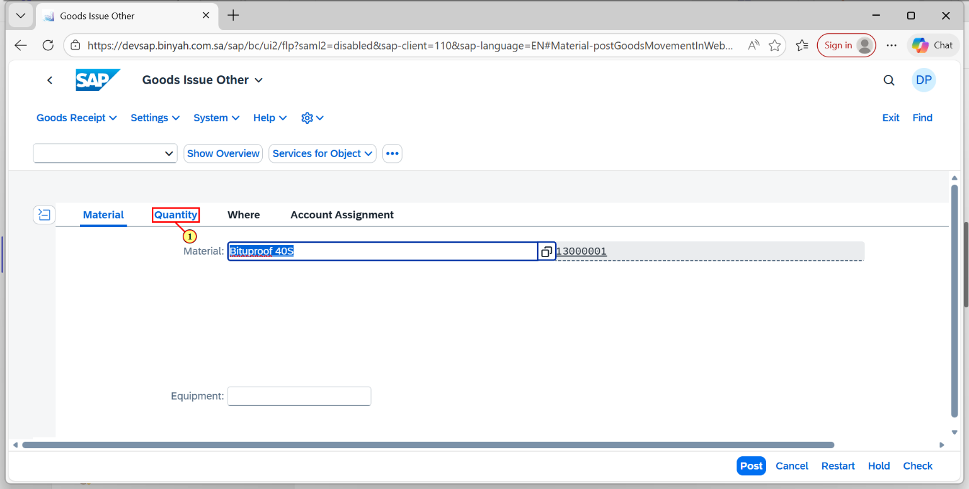
Step | Action
(1) | Click on Quantity Section.

Goods Issue Other - Personal - Microsoft​ Edge
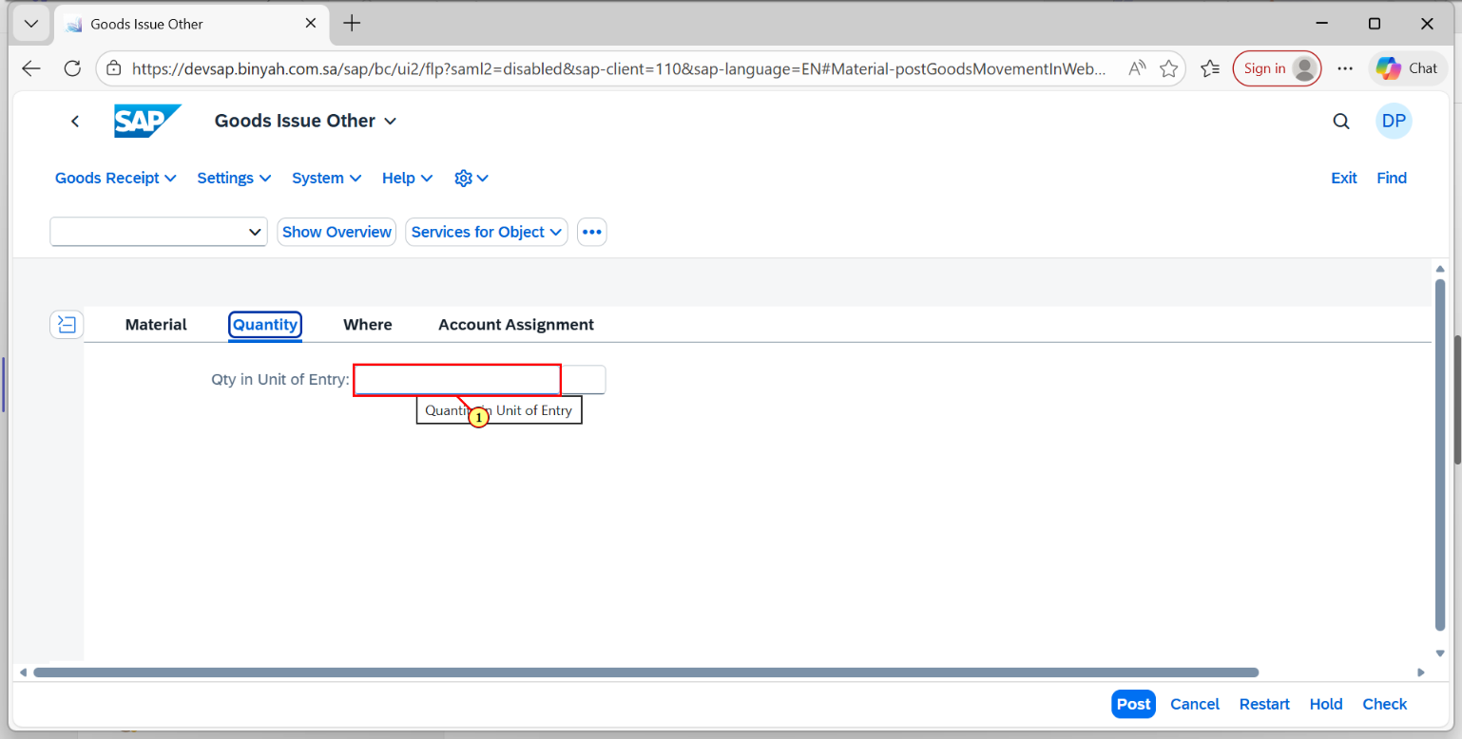
Step | Action
(1) | Enter the "Quantity".

Goods Issue Other - Personal - Microsoft​ Edge
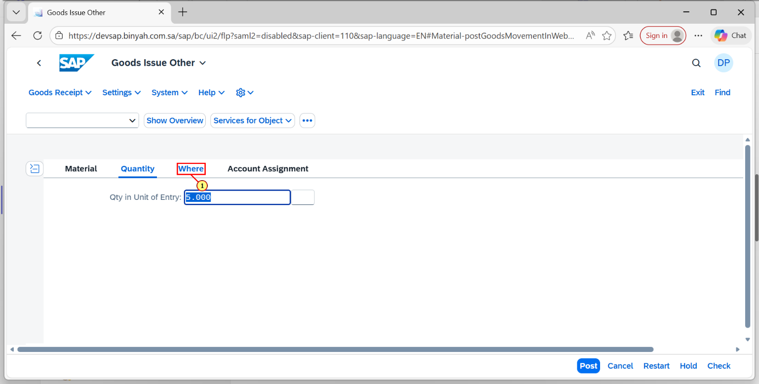
Step | Action
(1) | Click on "Where" section.

Goods Issue Other - Personal - Microsoft​ Edge
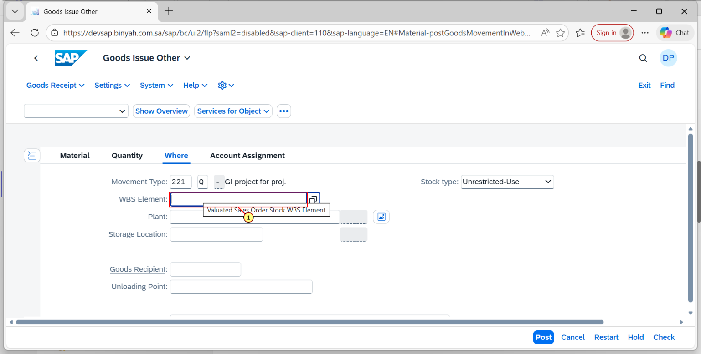
Step | Action
(1) | Enter the "WBS Element" for the corresponding material.

Goods Issue Other - Personal - Microsoft​ Edge
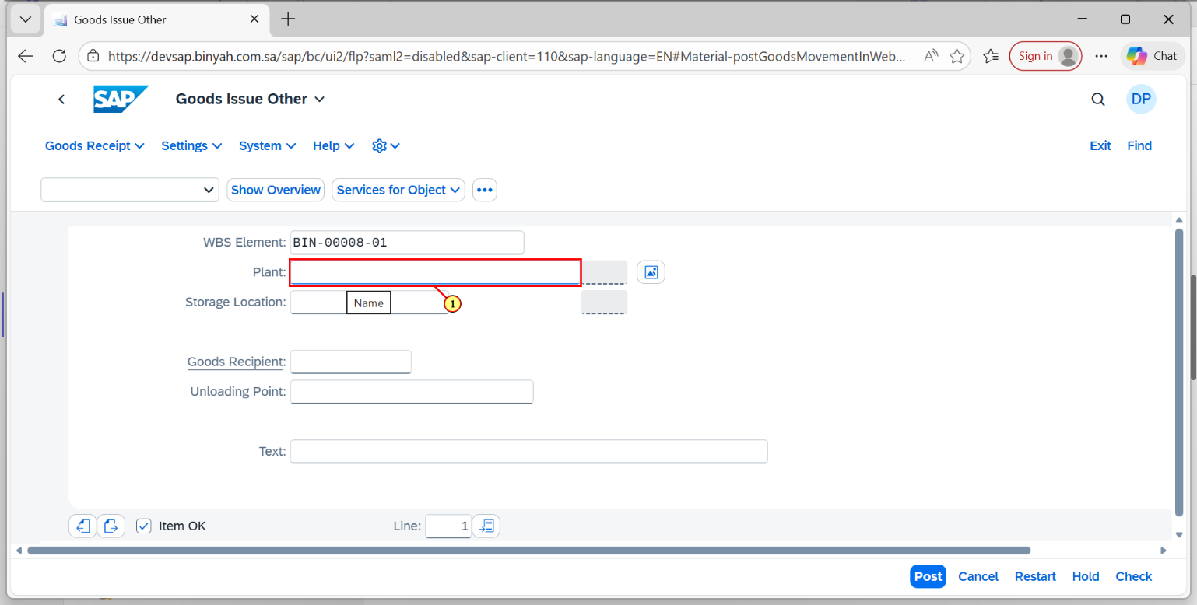
Step | Action
(1) | Enter the "Plant".

Goods Issue Other - Personal - Microsoft​ Edge
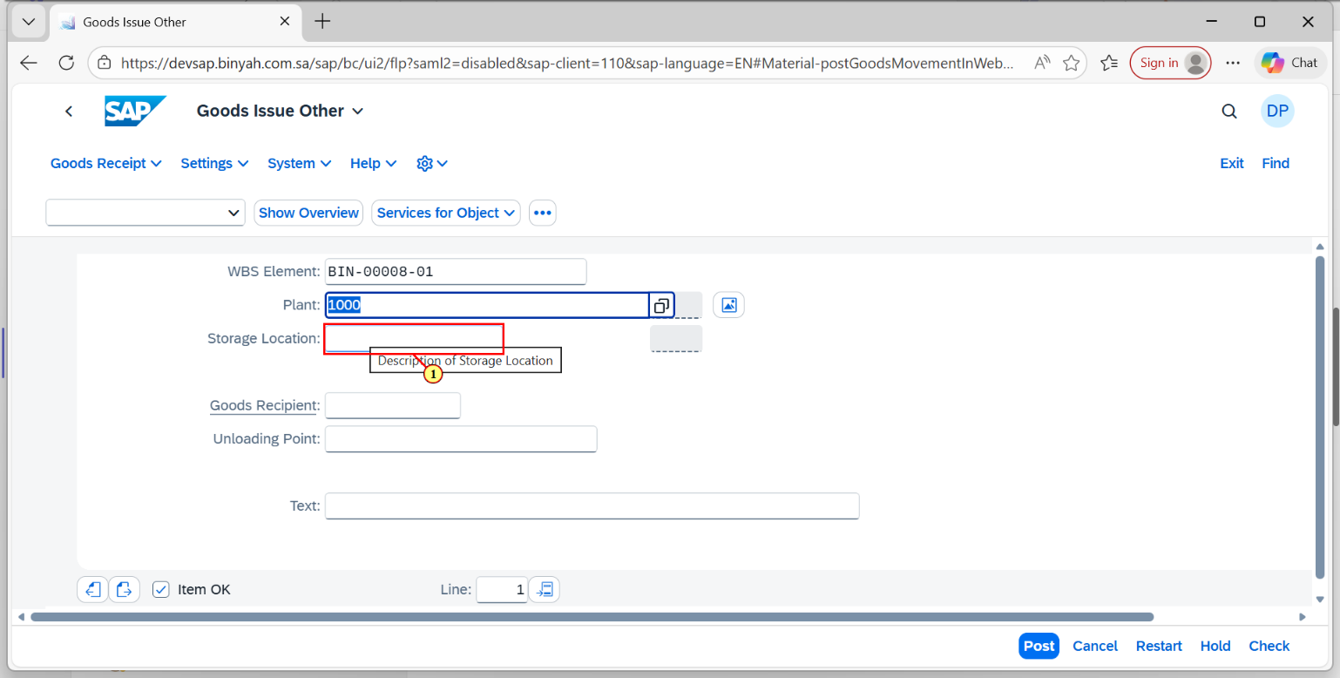
Step | Action
(1) | Enter the "Storage Location".

Goods Issue Other - Personal - Microsoft​ Edge
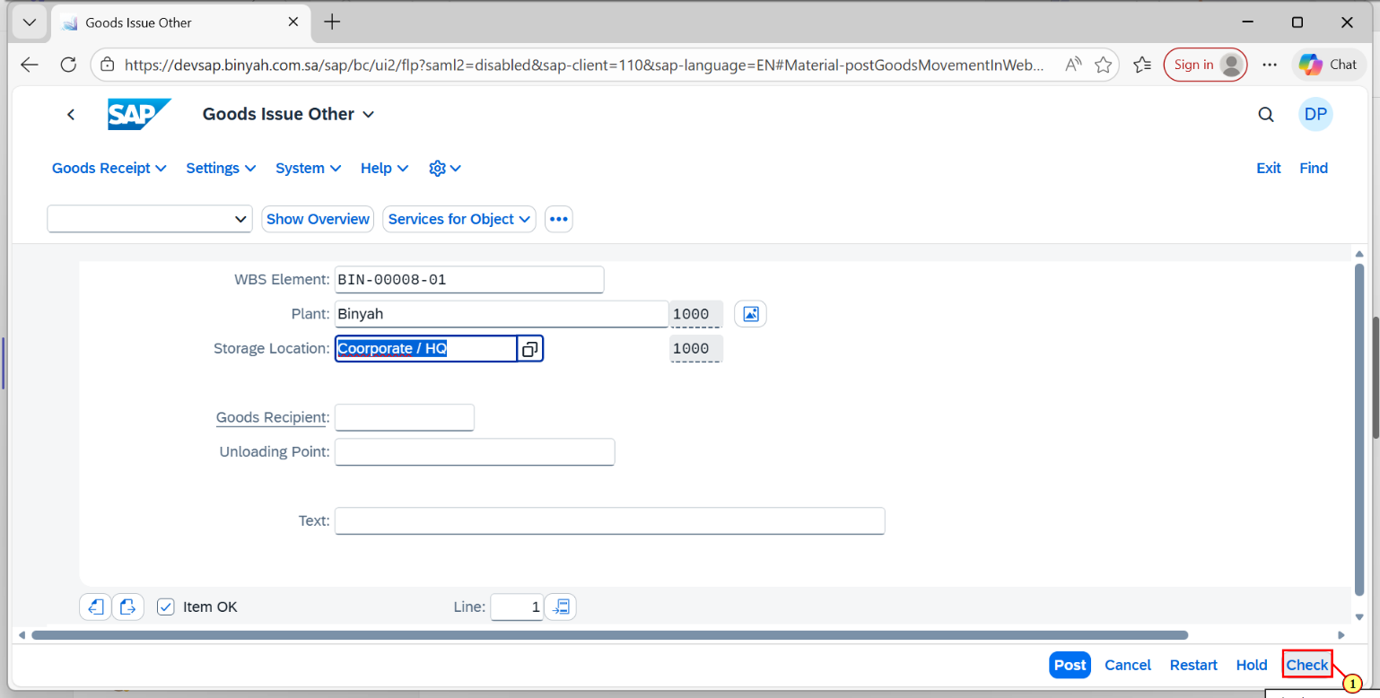
Step | Action
(1) | Click on "Check".

Goods Issue Other - Personal - Microsoft​ Edge
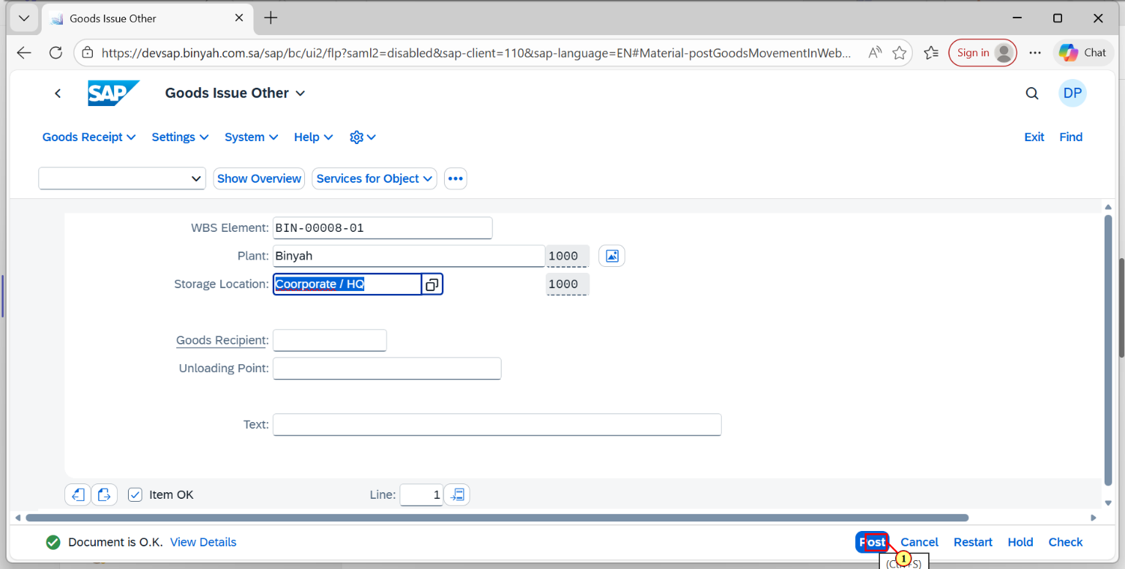
Step | Action
(1) | Click on "Post".

Goods Issue Other - Personal - Microsoft​ Edge
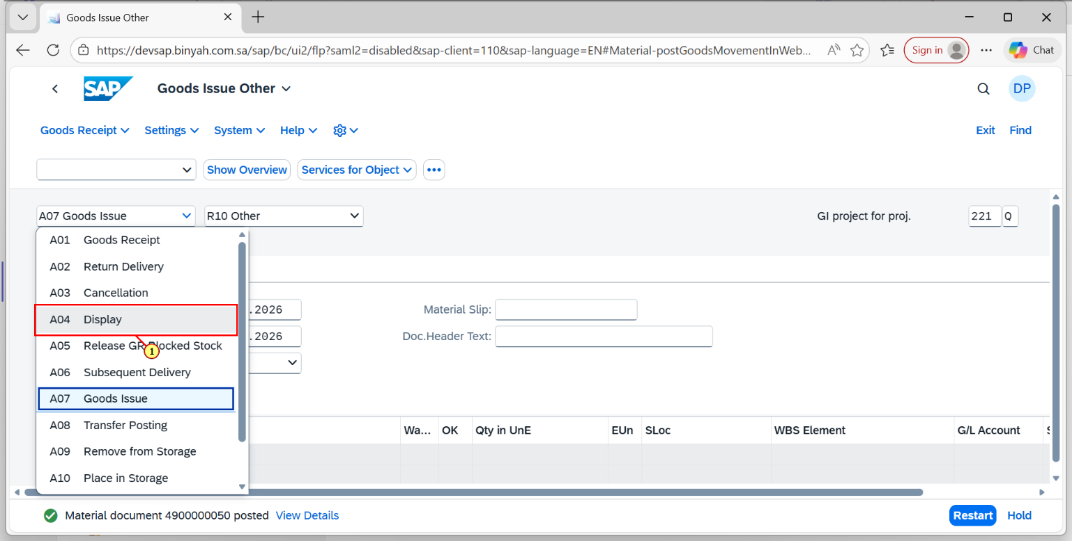
Step | Action
(1) | Again Click on "Display".

Display Material Document - Personal - Microsoft​ Edge
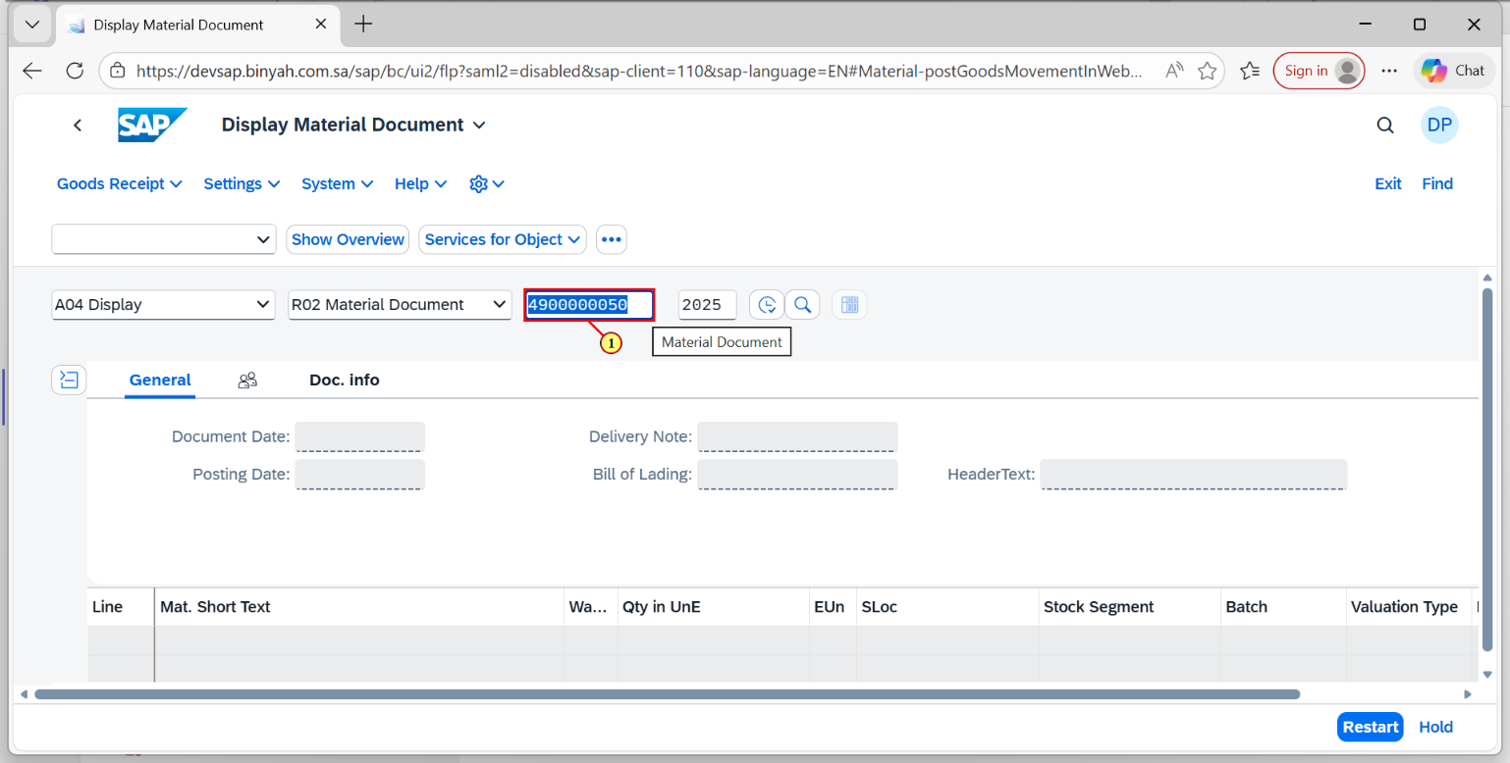
Step | Action
(1) | Enter the "Material Document Number".

Display Material Document - Personal - Microsoft​ Edge
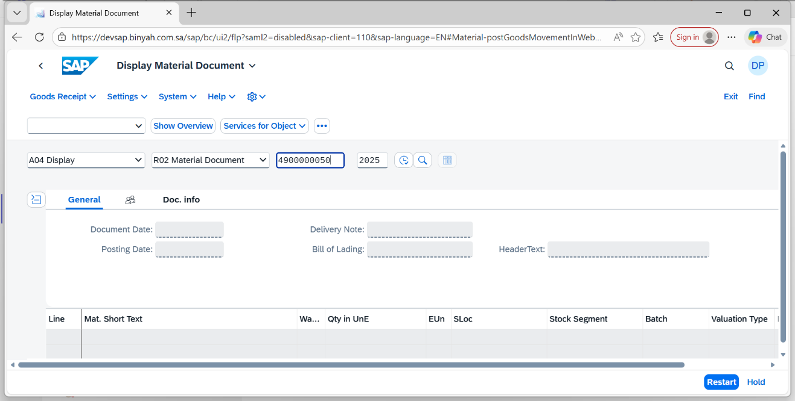
Step | Action
 | Press "Enter".

Display Material Document 4900000050 - Personal - Microsoft​ Edge
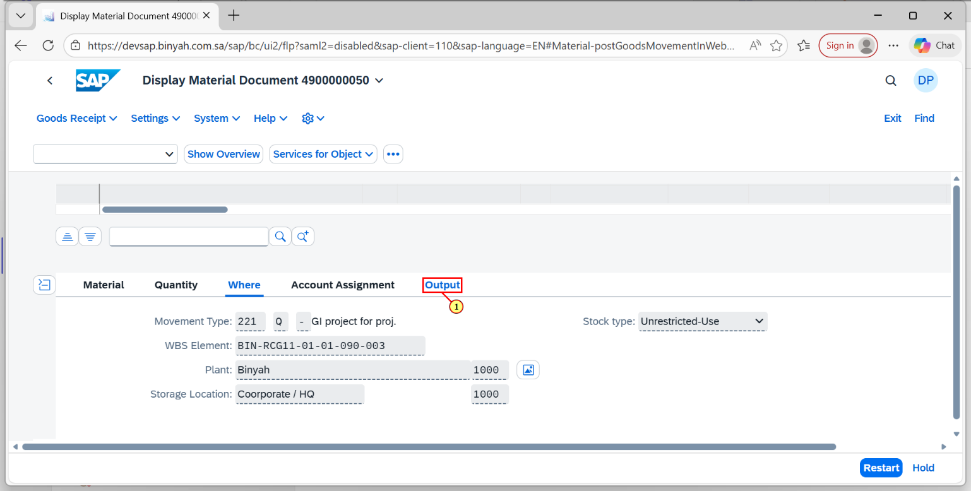
Step | Action
(1) | Click on "Output".

Display Material Document 4900000050 - Personal - Microsoft​ Edge
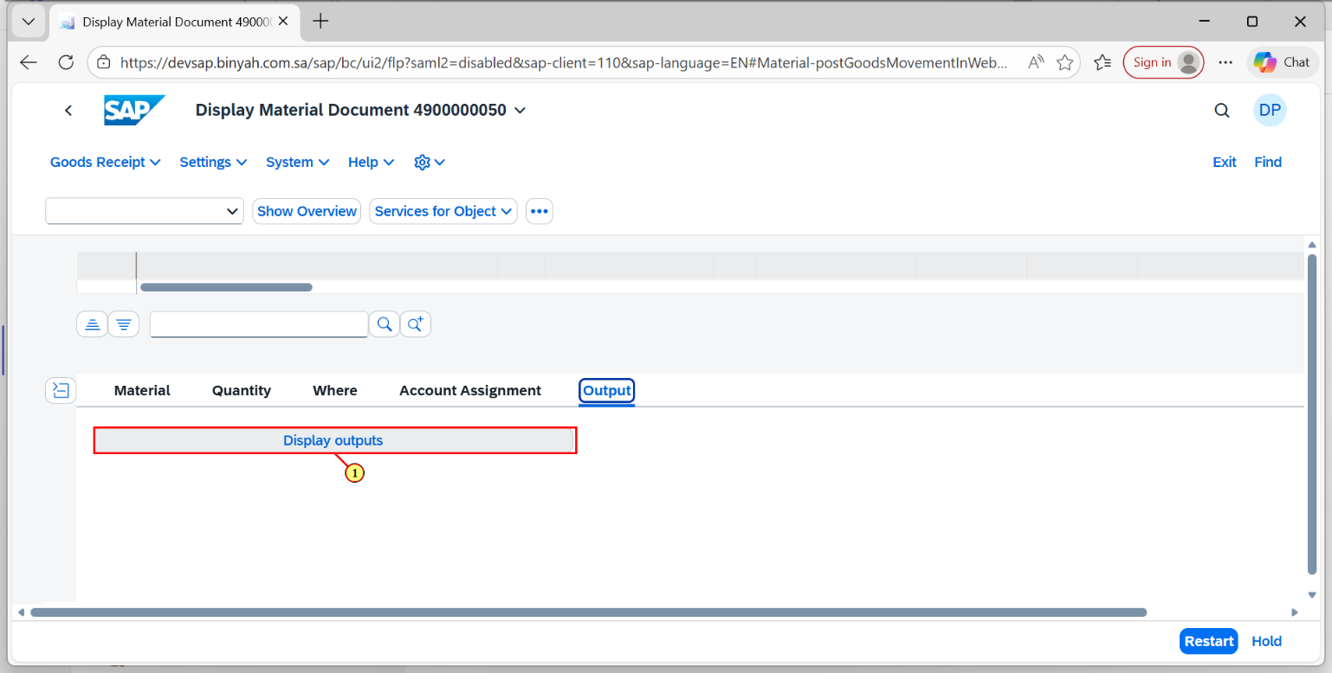
Step | Action
(1) | Click on "Display Outputs".

Material Doc.: Output - Personal - Microsoft​ Edge
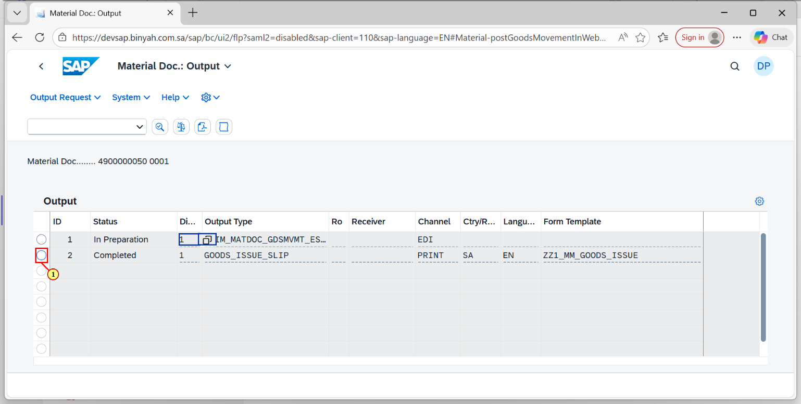
Step | Action
(1) | Click on "Document".

Material Doc.: Output - Personal - Microsoft​ Edge
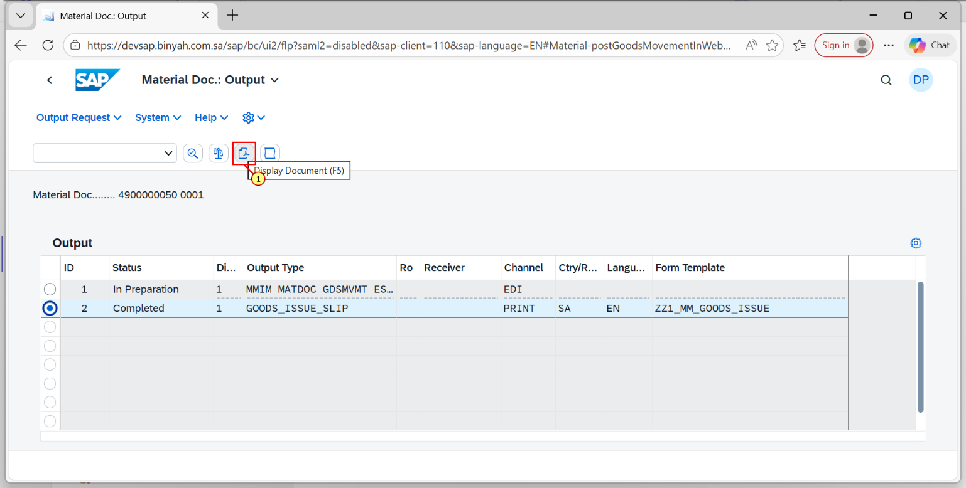
Step | Action
(1) | Click on "PDF Icon".

Material Doc.: Output - Personal - Microsoft​ Edge
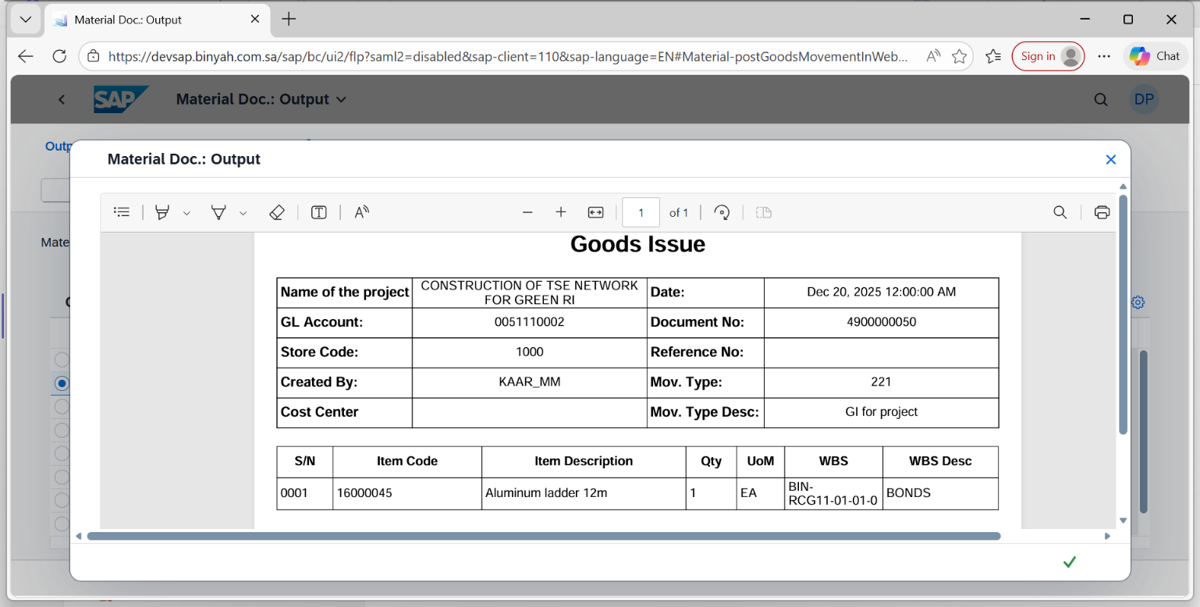
Step | Action
(1) | Material Document will be Displayed.

